ok, I started the project from scratch again.

I have a folder called black box in C drive as shown below: (I dont know if you can use total commander, but I use it instead of explorer. please let me know if this is ok)

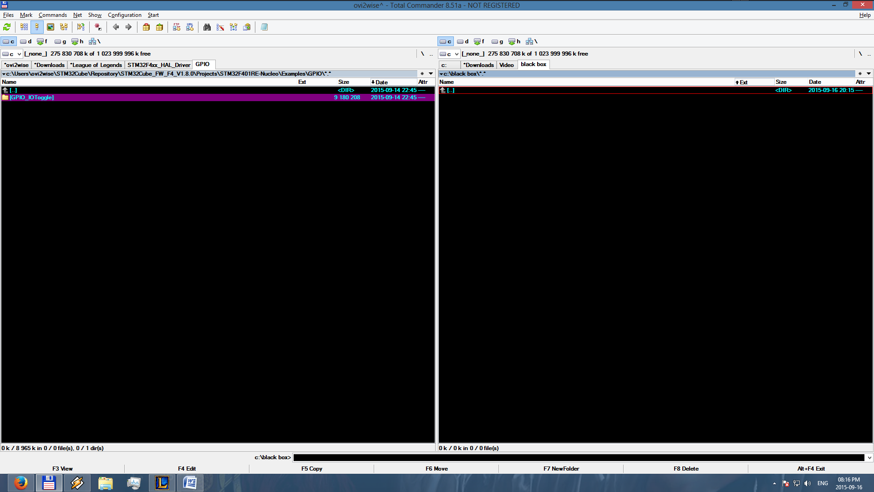



as you see, there are no settings in there at all. so I start ac6 and since my workspace is defined as this folder, a metadata folder is created with settings in it.

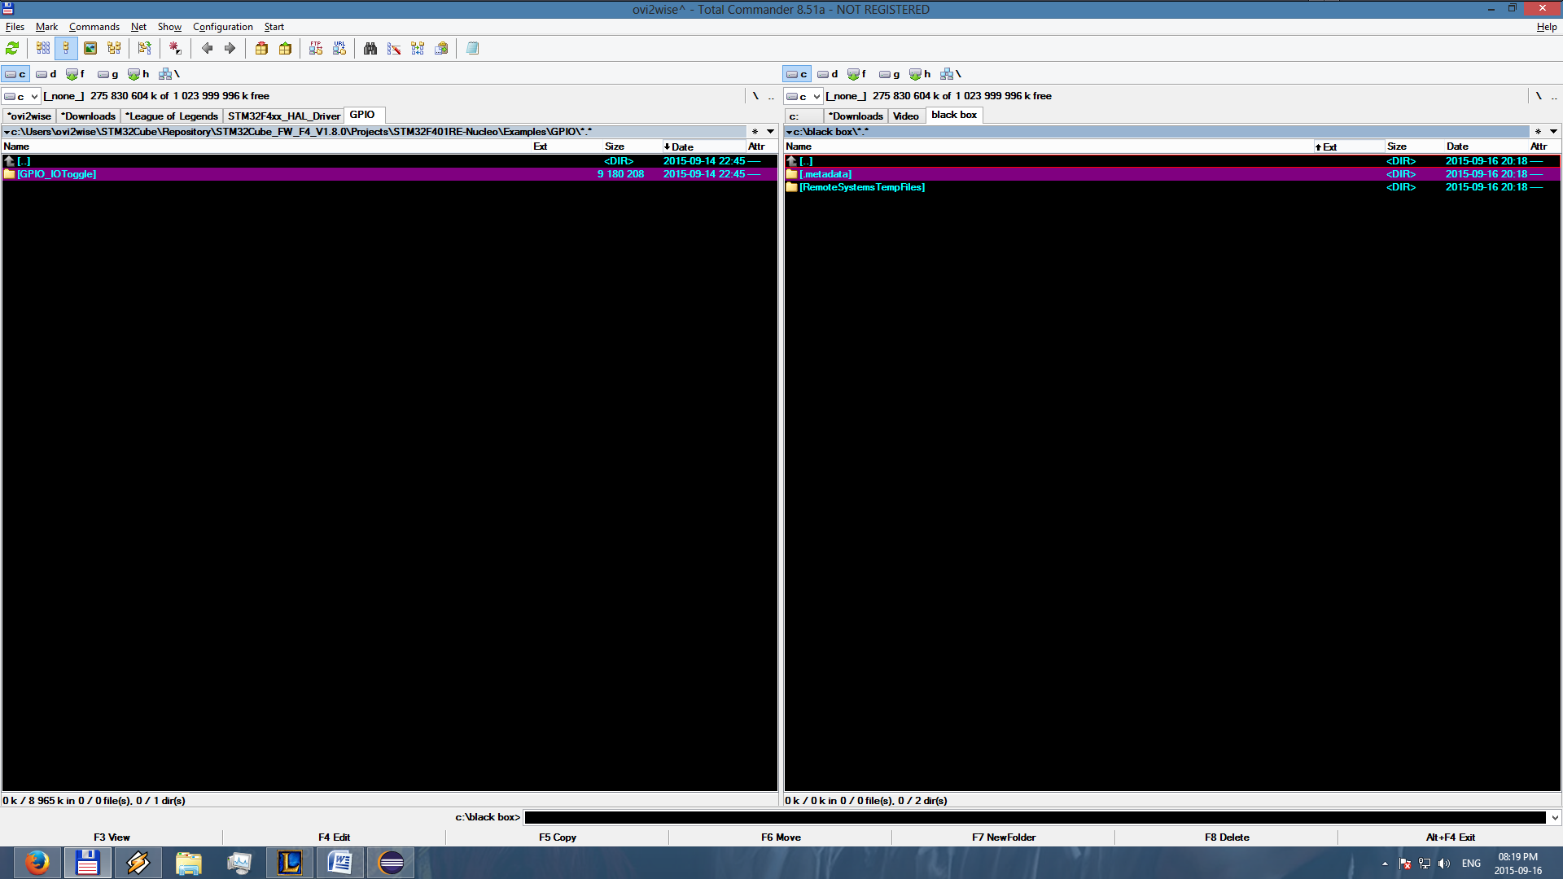

the first thing I then do is import as a general existing project

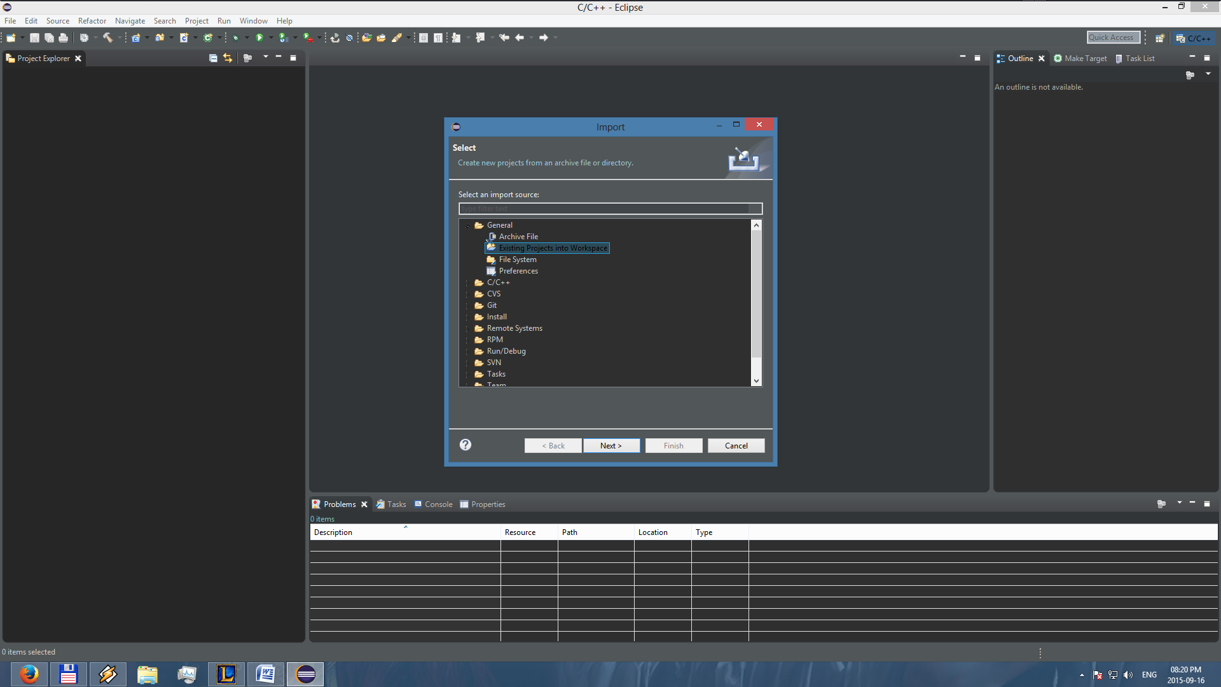

and then I try and import it. (please tell me if I use the right folder or not)

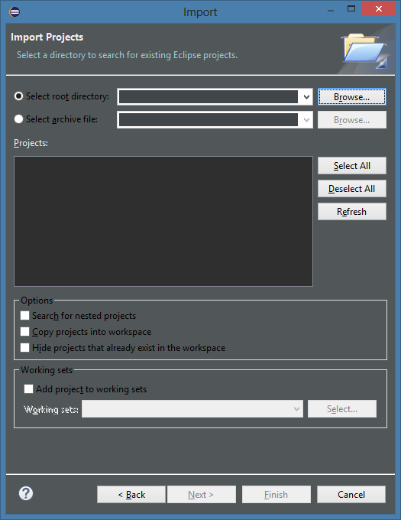 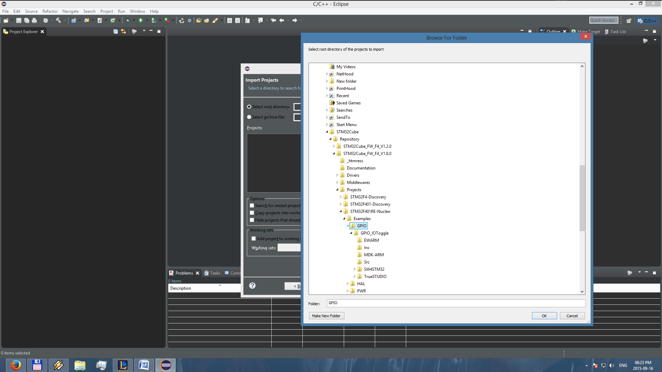

and as you can see, there are 2 versions of the project. if you look at the directories, you will notice a SW4STM32 version and a trueSTUDIO version.

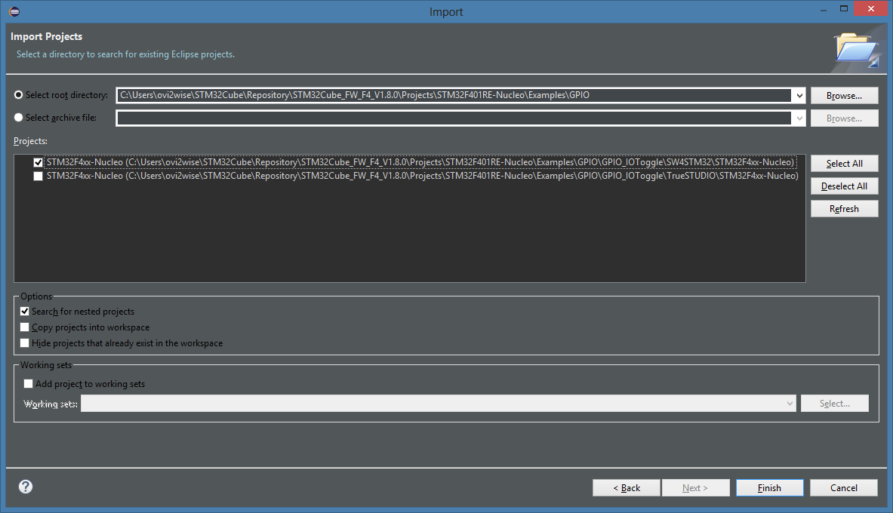

I can't remember where I read it but I remember reading that I should use the SW4 version. and this was further confirmed in your pdf

then I click finish and the project loads on my project space on the left pane

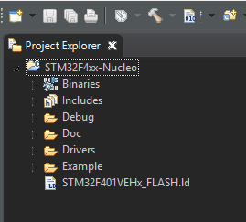

next, I right click on this project and select build project as shown:

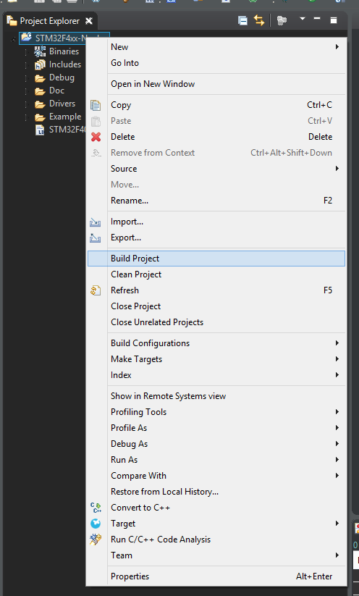

and immediately I get an error

