Windows 10 ST Development Setup

Stuff needed:
- Evaluation Board - STM32F407G-DISC1
- ST Programming tools
- Eclipse IDE
- OpenSTM32 development environment

Evaluation Board

Follow simple instructions
- plug in board to USB port (LEDs should light)
- plug in USB port
- press button and board acts as a mouse (more LEDs light as board is moved, tilted)

ST Programming Tools
The ST Programming Utility is used to provide access from the development environment to the hardware.

Download the STM32 ST-Link Utility

“STM32 ST-LINK Utility (STSW-LINK004) is a full-featured software interface for programming STM32 microcontrollers.”

http://www.st.com/content/st_com/en/products/embedded-software/development-tool-software/stsw-link004.html

Setup:
- Run the executable
- Installs the STM32 ST-LINK Utility program
- Installs device drivers

With the demo board plugged into a USB port, click on “Target” “Connect” . It will read the device and information about the processor on the evaluation board.

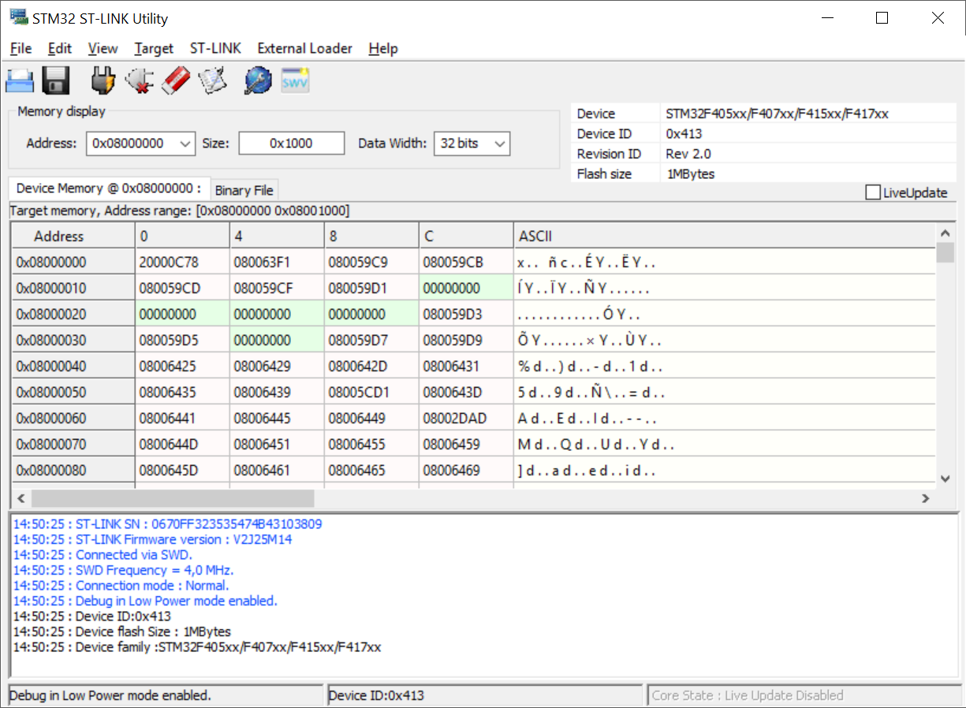
Click on “ST-LINK” “Firmware Update” - click the “Device Connect” button on the ST-Link Upgrade dialog box. This will read your version of firmware and show the newest version:

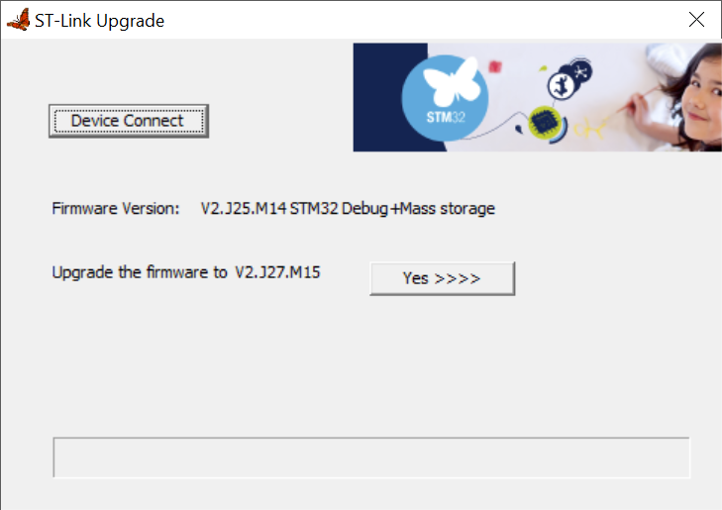

Click “Yess>>>>” to perform the upgrade.

Doesn't seem to be any automatic upgrade to this program. The version I just downloaded, from “Help” “About”:

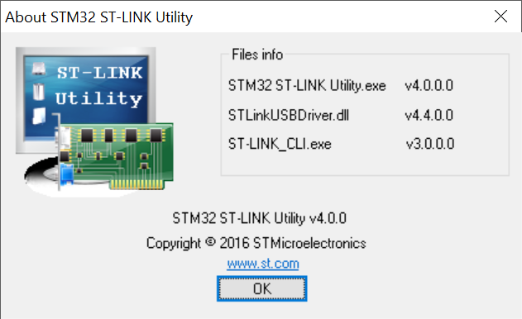

Eclipse
Eclipse is the development environment framework. It allows the OpenST environment to operate. I had to delete/unzip several times (but still not working yet!).

Download Eclipse
www.eclipse.org
http://www.eclipse.org/downloads/download.php?file=/technology/epp/downloads/release/kepler/SR2/eclipse-cpp-kepler-SR2-win32-x86_64.zip
Downloaded file is over 400MB

Install Eclipse

Unzip and run the installer. The unzip of 1,800+ files takes a while. One of the help files is very long, so the default path for the extraction should be shortened.

The Eclipse zip file is extracted – it doesn't really get installed. I created a shortcut to my desktop so I could use it like a real program.

When you run this for the first time, it asks for a workspace. I'm not using the default “USER” directory, so I entered my own directory:

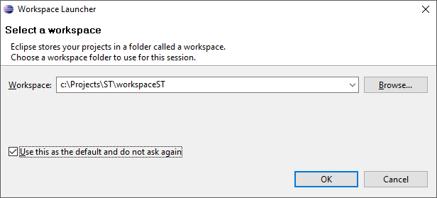

Update Eclipse

To Ensure you have all the latest software for your Eclipse environment, select “Help” “Check for Updates”

Do this first before installing the STM32 add on...but doesn't seem to help.

Install “other tools” first ?

From the “Help>>Install New Software” dialog box, click on “Available Software Sites” :
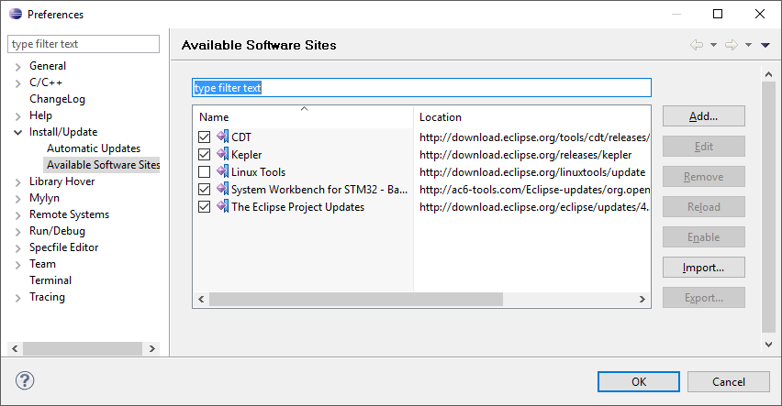

Select CDT, which is not selected by default. Click OK then click on Select ALL:

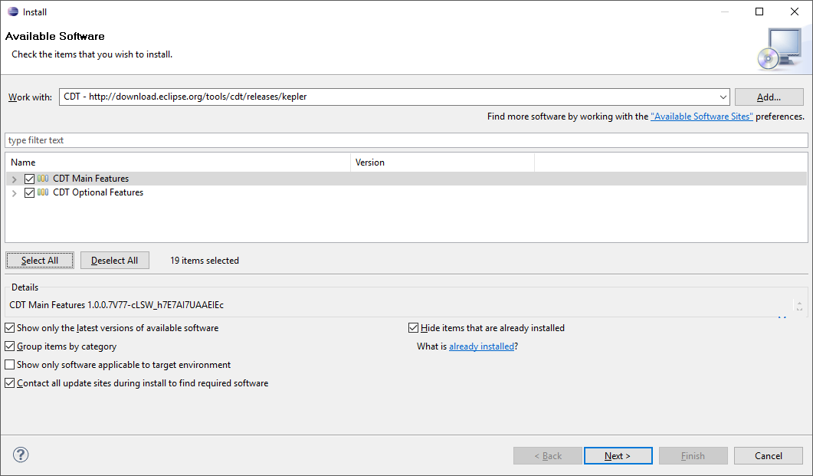
THIS DID NOT WORK....same error installing debugger (see below).

Select the Kepler / Mobile and Device Development tools:

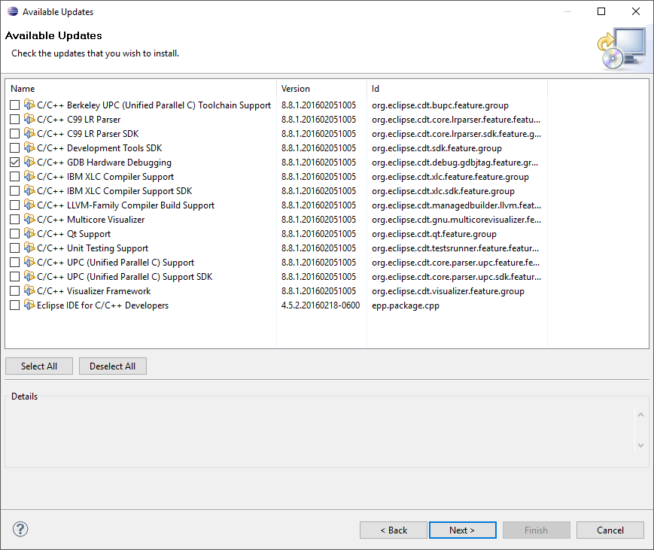

Same result...

Install System Workbench for STM32

This is from the instructions on the Openstm32 website.

You should Start Eclipse then open menu "Help >> Install New Software"; this will open the "Available Software" dialog:

Copy this link: http://ac6-tools.com/Eclipse-updates/org.openstm32.system-workbench.update-site-v2

You must then create a new update site, to be able to install System Workbench for STM32 - Bare Metal Edition:
- You should click on "Add:"
- Then give a name to the update site (System Workbench for STM32 - Bare Machine edition) and set the location to http://ac6-tools.com/Eclipse-updates/org.openstm32.system-workbench.update-site-v2
- Then click "OK" to create the update site
Then you should select all of the OpenSTM32 tools and click "Next>"

I
My Installation:

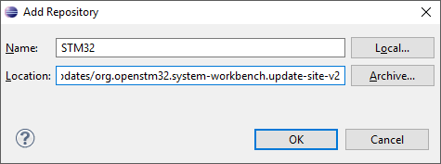

Which then allows you to select the “OpenSTM32 Tools”
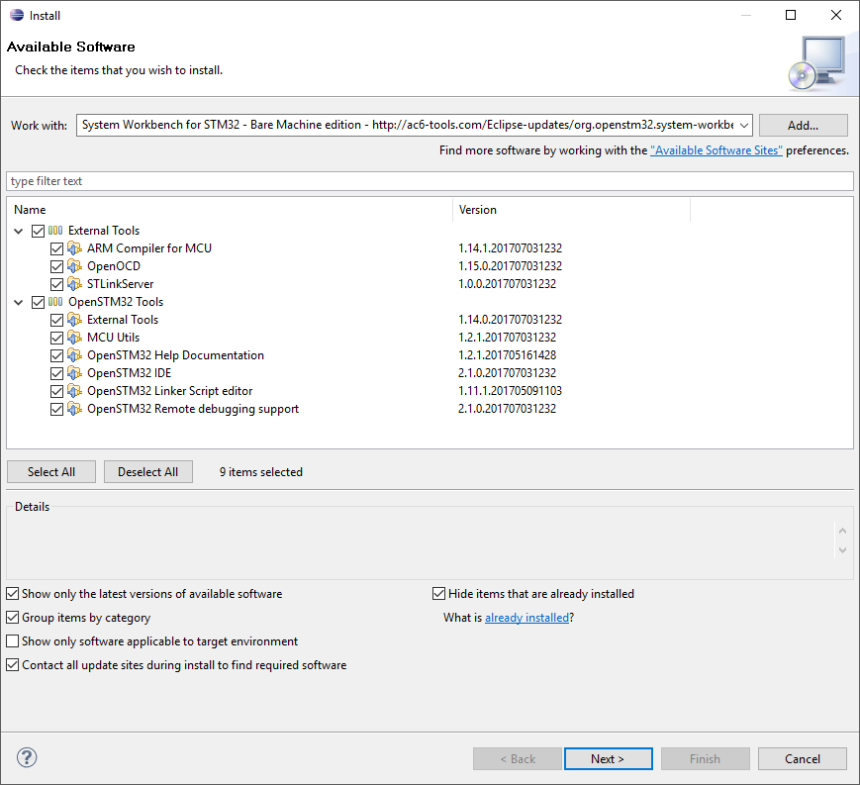

Clicking on “Next” will perform the installation process.

My installation could not be completed as requested – I selected only the debugging support so the error message was actually shown...

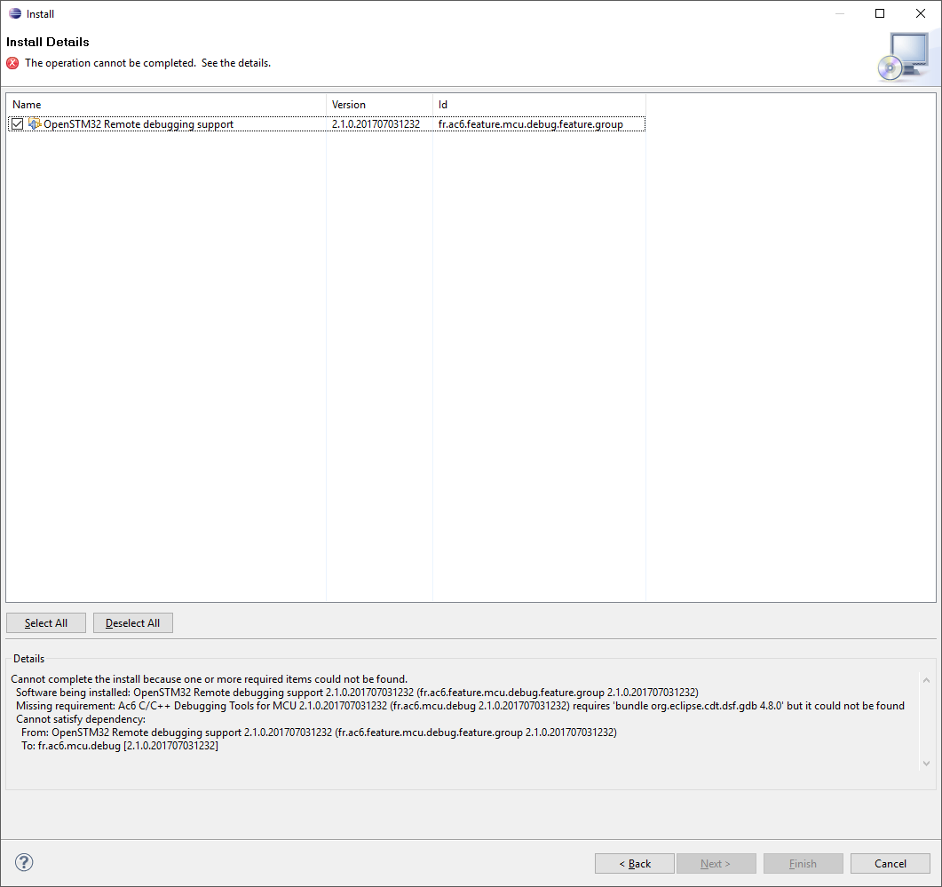

Click “Next” and finally click “Finish” to sign your life away:
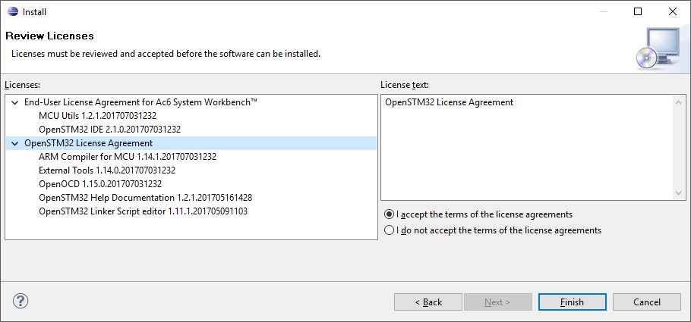
A reboot will be performed.

First Project

Select “Help” “Help Contents”
Find the SystemWorkbench for STM32 User Guide

Project / New / C-Project

MCU Configuration - selecting a predefined board did not bring in the debug operations.
Creating a new board definition:
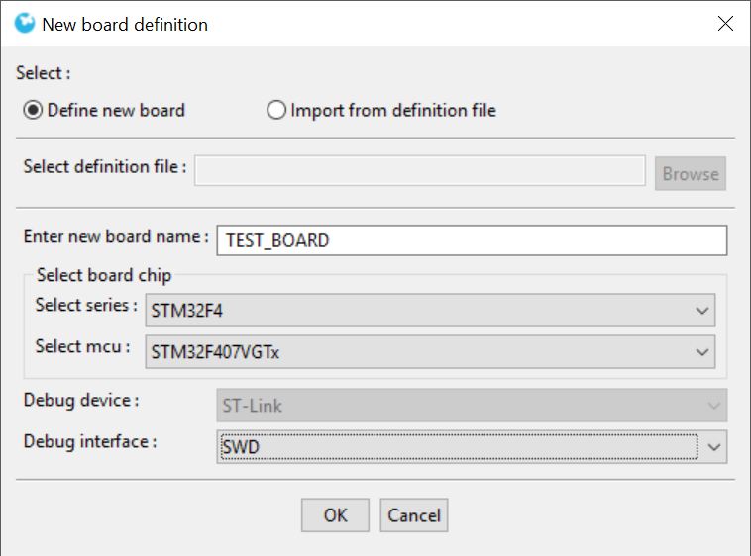

This shows up in the MCU Configurations as:

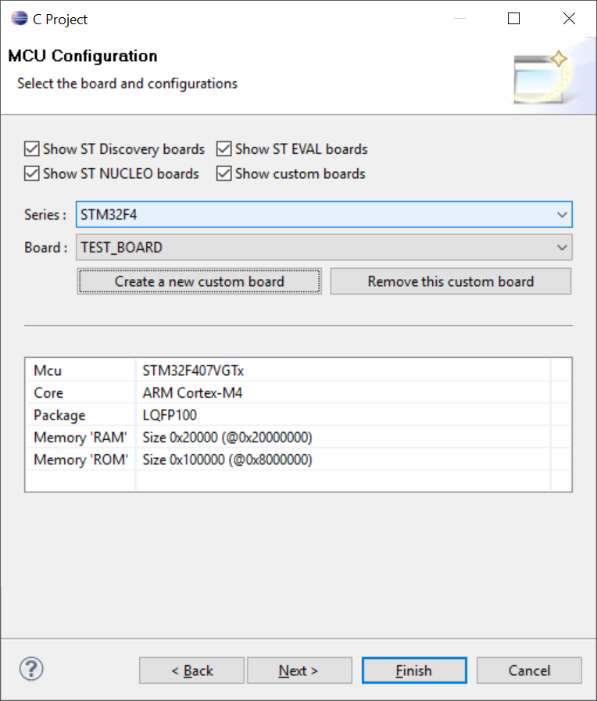

The project is now created – add in a simple main.c:

